MTSS Tier 1 Core Components Team

The purpose of this form is to conduct a team review of dissemination and implementation efforts regarding an integrated approach to Tier 1 level of supports with an MTSS Framework. Teams will use this as a guide to reflect on what is going well within and across Tier 1 components, as well as identify specific areas that represent opportunities for growth.

School-wide PBIS Team Review
Identify the step(s) you school is at with regard to implementing SW-PBIS with fidelity. Code each step as P = planning to implement, I = initial implementation of this step, FI = full implementation of this step, and M = maintaining full implementation through continuous improvement.
- Step 1 – Build consensus among staff on the importance of establishing a positive school culture and climate through common expectations and language regarding student behavior. Address the underlying belief barriers regarding the competition between extrinsic vs. intrinsic motivation (both work together rather than against one another)
- Step 2 – establish the common 3 to 5 positively stated, teachable, and memorable behavioral expectations using activities that allow staff input
- Step 3 – create a Behavioral Expectation by Setting (e.g., classroom, hallway, office, cafeteria, bathroom, playground areas, bus, etc.) matrix that outlines what it looks like to exhibit the behavioral expectations in the main settings in which students interact
- Step 4 – develop posters and other cueing materials that include the matrix for the area to signal to students when and how to exhibit the behavioral expectations. These posters should be placed in areas in which students can see with minimal effort.
- Step 5 – outline ongoing schedule of teaching and expectation review that will ensure students learn the expectations and know what it looks like in each of the matrix settings (school-wide assembly, rotational teachings, classroom-based instruction, role play of examples and non-examples, weekly announcements)
- Step 6 – develop a school-wide motivation/reinforcement system that consists of (a) a school-based currency to reinforce students who exhibit behavioral expectations, (b) grade-level or classroom incentives to access reinforcing experiences based on meeting expectations, and (b) staff maintaining high rates of behavior specific praise (5 to 1 ratio, praise delivered based on effort, behaviors, or process/strategies used)
- Step 7 – gather data to inform decisions
  - collecting and analyzing office discipline referral data – three voices (teacher view, student view, and administrative view, high flying students, location, type of behavior problem, preventive strategies implemented but not effective
  - student voice – degree to which students find school to be a fun and exciting place, sense of belonging and connection
  - student comprehension of the expectations (what are they, what do they look like, and rationale for exhibiting the expectations
- Step 8 – develop a system to monitor fidelity of implementation (teaching of expectations, reinforcement of students exhibiting the expectations, effectively responding to problem behavior, etc.) and meet as a team to review implementation and plan additional dissemination and professional development activities

Establish, Maintain, and Restore (EMR) Positive Relationships

Reflecting on intentional relational practices: To what extent are teachers in your building being intentional about EMR?
- What are the feasible, intentional and systematic approaches that are being implemented in your building to establish, maintain, and restore relationships with all students in each class?
  - Generate relational strategies or tactics that are used for each phase of the relationship
    - Establish
    - Maintain
    - Restore
- To what extent are there students in your building who do not have strong connections with at-least two adults in the building and a sense of belonging to the school environment?
  - What is your intention to address this area in the future?
    - Disseminate information through handouts, trainings, fidelity checks, and grade-level or PLC meetings
- To what extent are people aware of certain practices that may harm relationships with students (punitive discipline, lack of empathy for students who are struggling with stressors inside and outside of school, repeated failure without differentiated opportunities to be successful)?
  - What is your intention to address this area in the future?
    - Disseminate information through handouts, trainings, fidelity checks, and grade-level or PLC meetings

Social-Emotional Learning curriculum adopted and implemented

- Is your school implementing an SEL curriculum? If so, which one?
  - Are all students receiving the SEL curriculum?
  - Are teachers referencing the SEL skills throughout the week to promote the use of the skills outside of the lessons?
  - If a specialist is delivering the curriculum, is the teacher absent, simply present, or co-leading delivery of the lessons?
    - If the teacher isn’t participating, then they are unable to anticipate when skills can be used, reference the skill, and reinforce students for using the skill.
- If your school hasn’t adopted an SEL curriculum, what are your plans for adopting one and beginning implementation?

Proactive Classroom Management Strategies

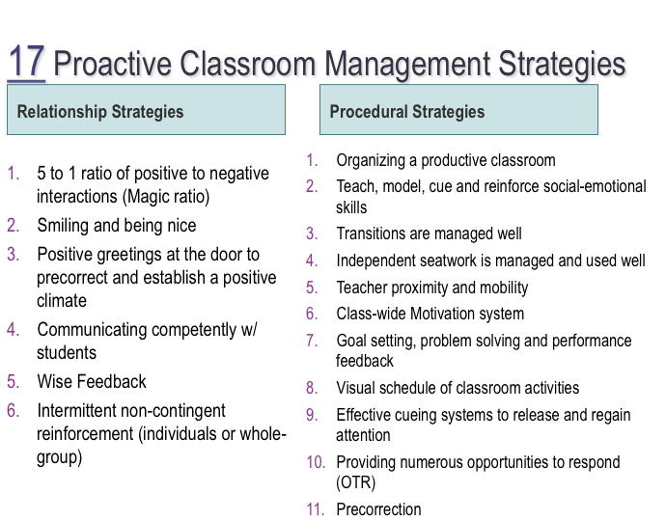
- Out of these PCM strategies, list which ones that have been identified as non-negotiable in your building?

- For those PCM strategies that have been trained on or information has been disseminated, indicate the degree to which they are being implemented school-wide by staff (less than 25%, 26-50%, 51-75%, and 76-100%).

- What is your team’s intention to improve dissemination and implementation efforts regarding PCM strategies in the future?
  - Disseminate information through handouts, trainings, fidelity checks, and grade-level or PLC meetings

Good Behavior Game

Has your staff received training or information on the implementation of the GBG and the long-reaching preventative effects it can produce?

What percentage of staff are currently implementing the GBG at your school?

- What is your team’s intention to improve dissemination and implementation efforts regarding the GBG in the future?

